Ғ.Әбдірахманұлы атындағы Қима орта мектебі

Friendship 2
(5 класс)

Өткізген: Ағылшын тілі пәнінің
мұғалімі, Самурат Н

2017-2018 ж
Short term plan

Unit 3 Values  Term 2  LESSON: Friendship 2 |  |  |  |  | School: Kiyma secondary school named after Gubaidolla Abdrahmanova
Date: |  |  |  |  | Teacher name: Samurat N
CLASS: 5 |  |  |  |  | Number present: 10 |  | absent: 0
Learning objectives(s) that this lesson is contributing to |  |  |  | 5.L2 understand an increasing range of unsupported basic questions which ask for personal information  5.S6 communicate meaning clearly at sentence level during, pair, group and whole class exchanges  5.C9 use imagination to express thoughts, ideas, experiences and feelings
Lesson objectives |  |  |  | All learners will be able to:
- develop listening skills through watching a story about “Lion and mouse”
- improve speaking skills by working in pairs, groups and whole class
- express ideas including emotions and senses
- portray various characters as roleplaying a story
- Describe your best friend
 |  |  |  | Most learners will be able to:
- develop listening skills through watching a story about “Lion and mouse”
- improve speaking skills by working in pairs, groups and whole class
- express ideas building simple sentences
- portray various characters as roleplaying a story
- work with book
 |  |  |  | Some learners will be able to:
- develop listening skills through watching a story about “Lion and mouse”
- improve speaking skills by working in pairs, groups and whole class
- express ideas building extended sentences
- portray various characters as roleplaying a story
- work with book
Language objectives |  |  |  | Use present simple , adjective
Value links |  |  |  | Respect, Support the friends
Cross curricular links link |  |  |  | Psychology
ICT skills |  |  |  | Smart board for presenting a video
Intercultural awareness |  |  |  | Students will be able to understand that significance of friends role in the human life
Kazakh culture |  |  |  | Students will be able to value the work in Kazakh culture
Pastoral Care |  |  |  | Students will be able to understand the importance of respecting values
Health and Safety |  |  |  | Everyday classroom precautions will ensure that safety measures are provided to prevent the exposure of electrical power cards
Previous learning |  |  |  | Friendship 1
Plan
Planned timings | Planned activities |  |  |  |  |  | Resources
Lesson 1  Beginning  5-min | Class organisation  Warm-up and lesson objectives presentation  Warm-up (W, I)  Learners are organized into the circle to describe their friends  Watch the video and guess the topic (W)  Watching the video the learners are asked to predict the topic of the lesson.  Teacher introduces the lesson objectives. |  |  |  |  |  | PPT  https://www.youtube.com/watch?v=vnVuqfXohxc
Middle  6-min  1-min  7-min  8-min  1-min  7-min | Vocabulary (W)  1.Introducing the new words with happy, angry face.  2. They open dictionaries then write down the new words  - Squeak [skwiːk] гүрілдеу  - Slide [slaɪd] қозғалыс  - Laugh[lɑːf] күлкі  - Wide[waɪd] кең  - roar [rɔː] қарқылдап күлу  3. Teacher asks learners to put the words into correct group and check as a whole class.  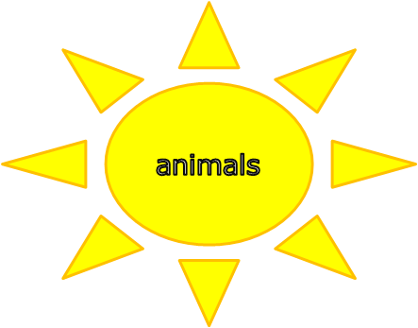  (Little, kind, big, lion, wide, slide, walk, run, squeak, laugh, mouse, roar.)  noise  ADJECTIVES  movement  Lead-in (W, I)  Pre – listening  Work with pictures.  Students, look! What is it? Students: it is a lion.  Teacher asks students if a lion and a mouse can be friends. Why yes or no? Why?  While - listening (I)  Task 1. Listen to the story and put the pictures in order.  Task 2. Write the number of the picture in exercise 1.  Students listen to the story correctly then they put the pictures in order.  They will do 2 tasks.  They will check their answer.  Descriptor: I will provide for less able learners prompt support  Post- listen in  Role play (G)  Learners in 3 (narrator, lion, mouse) role-play the story.  1. They will read a story about “ The lion and the mouse”  2. Three students will be a narrator, a lion, a mouse. 3. Students will play role play.  Differentiation  Less able students are let to read the roles from the text.  Warm up  Students stand all together and do exercise with verbs and adjectives. For example: big, small, wide, slide, squeak, laugh, roar, walk, run.  Writing. (W) Describe your friend using adjectives.  Pupils will tell their best friends  Pupils will describe their friends. |  |  |  |  |  | PPT  PPT  Handout 1  https://learnenglishkids.britishcouncil.org/ru/short-stories/the-lion-and-the-mouse  Handout 2
End  5-min | Reflection (W)  Teacher asks students could a lion and a mouse be friends ? Why?  Teacher asks students remember that everyone has different talents and abilities.  Self assessment. Using five fingers.  If they completely understand to show five fingers  If they mostly understand to show four fingers  If they understand pretty well show three fingers  If they could use more practise to show two fingers  If they need help to show a finger  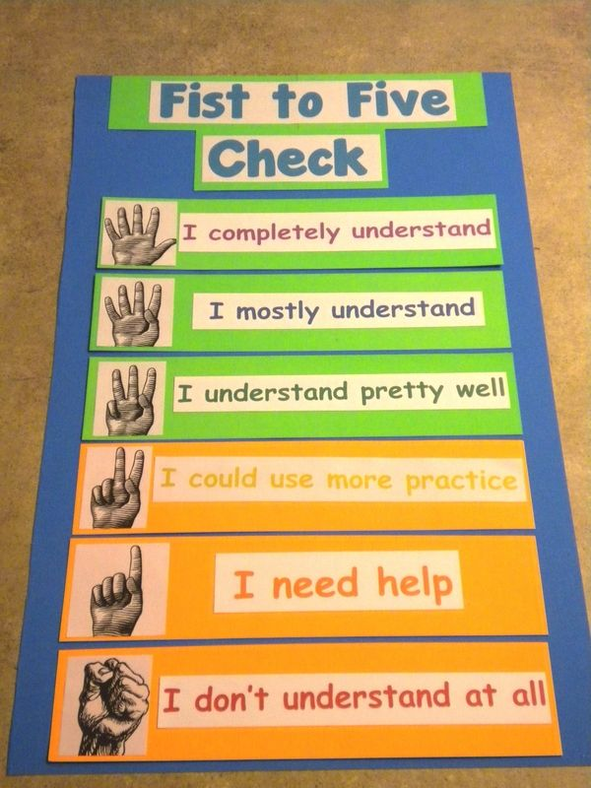  Home task: Make up sentences using new words |  |  |  |  |  | PPT
Additional information
Differentiation – how do you plan to give more support? How do you plan to challenge the more able learners? |  |  | Assessment – how are you planning to check learners’ learning? |  |  | Cross-curricular links  Health and safety check  ICT links  Values links
- More support can be given at the start and in middle of lesson by providing less-able learners with story vocabulary in a word list so they can read examples of words seen or heard.  - Learners who are less confident at making up dialogue, can be given copies of parts of the dialogue from the story to read aloud.  - More-able learners can be encouraged to use the full range of language from the video when they practise the role-play. |  |  | - Monitor how much vocabulary learners can recall from images on the video without sound and then from video with sound.  - Monitor learners as they reorder events from the story. Can they read and understand each event and can they sort them into chronological order? Notice any sentences which are difficult for learners to understand and adapt for a future lesson.  - Monitor groups of learners as they agree on and practise dialogue for the role-play activity. Do they take turns to speak? Do they contribute appropriate language for the role-play? |  |  | - Links to the L1: Do learners know this story in the L1 and do they know any other Aesop’s fables?  - Make sure learners have sufficient space to act out the role-play.  - As the unit is on the topic of values, it is very important to leave time to discuss the end two questions with the whole class.
Reflection  Were the lesson objectives/learning objectives realistic?  What did the learners learn today?  What was the learning atmosphere like?  Did my planned differentiation work well?  Did I stick to timings? What changes did I make from my plan and why? |  | Use the space below to reflect on your lesson. Answer the most relevant questions from the box on the left about your lesson.
Summary evaluation

What two things went really well (consider both teaching and learning)?

1:

2:

What two things would have improved the lesson (consider both teaching and learning)?

1:

2:

What have I learned from this lesson about the class or individuals that will inform my next lesson?

